**The Success Story of Orange Flesh Sweet Potato (OFSP) Production and Seed Multiplication in The Welmeltika Scheme**

Welmeltika irrigation scheme Bale Zone Harena Bulluk Woreda. Vitamin A has been found as one of the most deficient nutrients at the population level around Welmel Tika schemes (Berhanu et al., 2021). The program has started interventions with the capacity building of training and introduction of vitamin A-rich orange-flesh sweet potato seed multiplication and production. It was carried out through coordinated and collaborative efforts with PASIDP-II and ICRISAT. Therefore, in 2020/2021, three model farmers were given access to more than 19,000 cuttings of three kinds (Dilla, Kabode, and Alamura) for the cutting-based multiplication of orange flesh sweet potato seeds. In 2022, the orange flesh sweet potato participatory on-farm research and demonstration production and seed multiplication with cuttings expanded from three farmers to 15 farmers with 3.75 hectares of land and produced 2163 quintals of yield. The orange flesh sweet potato seed multiplication and production technologies extension has been done through Agronomy & extension advisory support of woreda and kebele experts. The on-farm research and demonstration participant farmers shared their experiences through field days. Exchanged OFSP cuttings to their neighbor farmers. Besides so many farmers participated in farmers' field days and shared practical experiences. Now in Welmel tika kebele, the orange-fleshed potato production expanded to 70 hectares and this technology scales out to the other 5 kebeles

Ato Dame Tahir, a specific farmer, resides in the Harena Buluk Woreda welmaltika kebele. Ato Dame Tahir in 2020/21 initially grew/planted 4000 cuttings of an orange flesh sweet potato on 0.016 hectares of land and now he has covered 0.125 hectares of orange flesh sweet potato. As a result, in 2021/22, he earned a total of 19,000 ETB from the sale of cuttings & tubers. With the money he had made, a new business of fattening by purchasing an ox and two goats. He also started adding this orange- fleshed sweet potato as another nutrient-dense crop variety to his family's meals. Currently, this farmer is seen as a model farmer so other farmers start following up on his success practice.

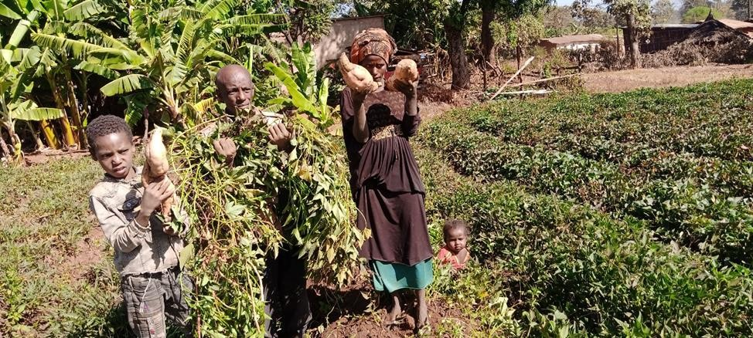 Ato Dame Tahir with his family on orange flesh sweet potato plot.

**The Success Story of Papaya Producer Farmer in Otora Scheme**

Otora small-scale irrigation scheme is found in the SNNP region, Gamo Zone, Gerese Woreda. Ato Germu Ganjula 42 years old, lives in Dambile kebele and is one of the beneficiaries of Ottora irrigation scheme. He has 0.125 ha of land in Othora irrigation development.

Before the PASIDP-II intervention, Ato Germu Ganjula depends on rain-fed crop production, harvested once a year and mostly consumed at home. The Area is drought-prone and high variability in rainfall such as erratic rainfall, uneven distribution, and dry spells impact low crop productivity and yield reduction, resulting in low income and food insecurity.

Later on, after the PASIDP-II intervention, Ato Germu Ganjula started irrigation crop production in the year 2018/19. Ato Germu Ganjula said “he did not know about fruits production and nothing about growing fruits. But after Woreda agricultural development office and Arbaminch research center provide training on fruit production, he built relationships and trust with extension workers and he was happy to try fruit production.” He was a member of FREG (farmers research and Extension Group) and conducted on-farm research and demonstrations of papaya fruit production, The woreda and kebele extension worker as well as the Arbaminch research center provide improved varieties, on-farm training, and technical support.

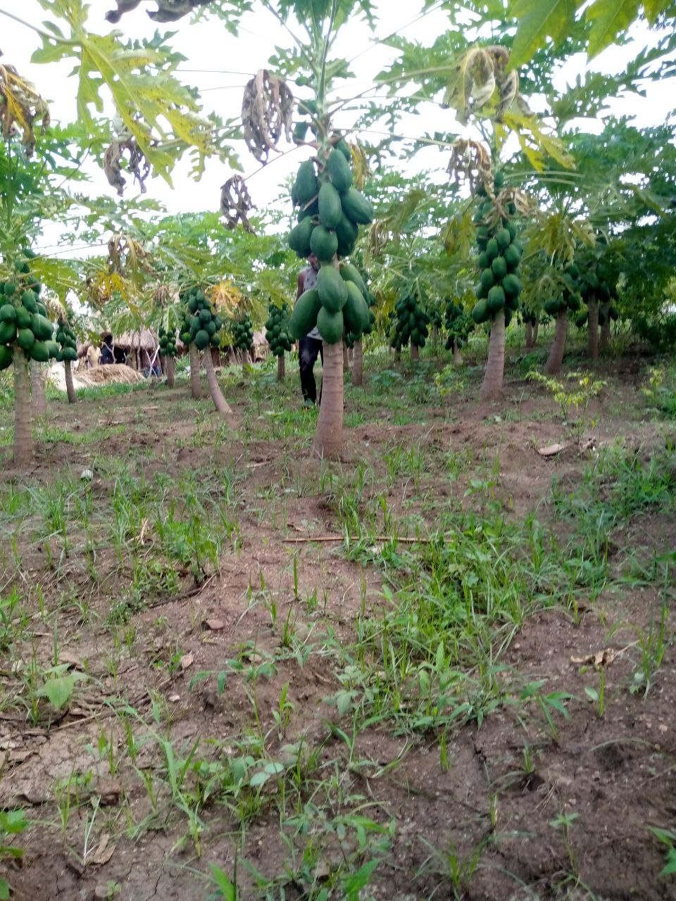Ato Germu Ganjula told us that “after the demonstration, he gained experience, observed the results of the demonstration, and now he has been engaging in papaya production with intercropping of haricot bean.” This year Ato Germu Ganjula harvested 56.12 Quintal of papaya and 2.5 quintals of haricot bean from the same 0.125 hectares of land with a gross income of 43,034 birr and variable cost of 11,530 birrs. His success is reflected in the fact that he earns a net annual income of 31,504birrs (table one) below. He improved his livelihood, besides papaya produced is consumed at a household level ensuring the family, especially women, and children are getting a good supply of vitamins. Furthermore, he delivers and shares his experience with neighboring farmers.

|  |  |  |  |  |  |
| --- | --- | --- | --- | --- | --- |
|  | Activities | Unit | Amount | Unit price birr | Total sale birr |
| **A. Gross income** | Production of papaya yield from 0.125 ha of land | quintal | 56.12 | 700 | 39284 |
| Production of haricot bean yield from 0.125 ha of land | quintal | 2.5 | 1500 | 3750 |
| Gross income sum |  | | | 43034 |
| **B. Variable cost** | Land preparation | Oxen-days | 4 | 500 | 2000 |
| Land preparation | Person-days (PD) | 3 | 300 | 900 |
| Manure preparation and application | Person-days | 3 | 300 | 900 |
| Watering (irrigation) | Person-days | 4 | 300 | 1200 |
| Weeding and hoeing | Person-days | 4 | 200 | 800 |
| Harvesting | Person-days | 4 | 200 | 800 |
| Bagging and handling | Quintal | 3 | 150 | 450 |
| Transportation cost | Quintal | 56 | 80 | 4480 |
| Variable cost sum |  | | | 11530 |
| **C. Net income** | A-B |  |  |  | 31504 |

**The Success \of FREG Farmer Research Extension) Participant Farmers in Banana Production at Shawe Small-Scale Irrigation**

Shawe small-scale irrigation scheme is found in Oromia region, Bale Zone, Harena Buluk Woreda. The scheme has suitable agroecology and a large potential for banana production. Farmers use bananas as a means of food consumption and income generation activities. However, most of the banana production in the area was based on local cultivar which is low-yields, and susceptible to disease, and limited provision of production technologies such as improved varieties and crop management practices.



Hence to address these problems on-farm demonstrations and evaluation of improved banana varieties were done through the FREG approach in Shawe small-scale irrigation schemes, in collaboration with the Sinan research centre, woreda, and kebele agricultural extension workers and beneficiaries’ farmers.

Yusuf Adam, 45 years old, lives in Shawe kebele, Harena –Buluk Woreda, a house-headed man with his wife and 10 children. He is one of the members of FREG. Before the intervention, Yusuf Adam had very limited access to an improved variety of bananas and skill gaps in production techniques. Yesuf Adem was elected by the villagers as one of the most active participants in FREG on-farm research and demonstration of banana production. He has got training and after attending the training he was provided with demonstration inputs on 64 high-yielding and marketable improved varieties of banana suckers planted within 0.04 hectares of land. The woreda and kebele extension workers and Sinana research centres gave frequent technical support and follow-up. The result was impressive when compared to the local variety. After the intervention, everyone in the family is happy and has been working in crop management such as weeding, hoeing, watering, etc. and Yesuf Adem expanded the banana plantation from 0.04 to 0.5 hectares of land.

He got income from a banana finger sale of about 40000 birrs (one bunch of fruit is sold by 200 ETB up to 300 ETB) and from a sucker sale of 6,0000 Birr (one sucker sold from 70 -100 ETB) a total of 100, 000 Birr. Thus, with the money got from the sale of the product he constructed 32 corrugated iron sheet houses for 56000 birrs, and with the rest, money started the oxen fattening business, which was a new source of income for his family. Yesuf Adem increased his income, his children attended school, paid school fees, bought clothes for his family, and consumed them at the household level ensuring the family, especially women and children were getting a good supply of vitamins and minerals.